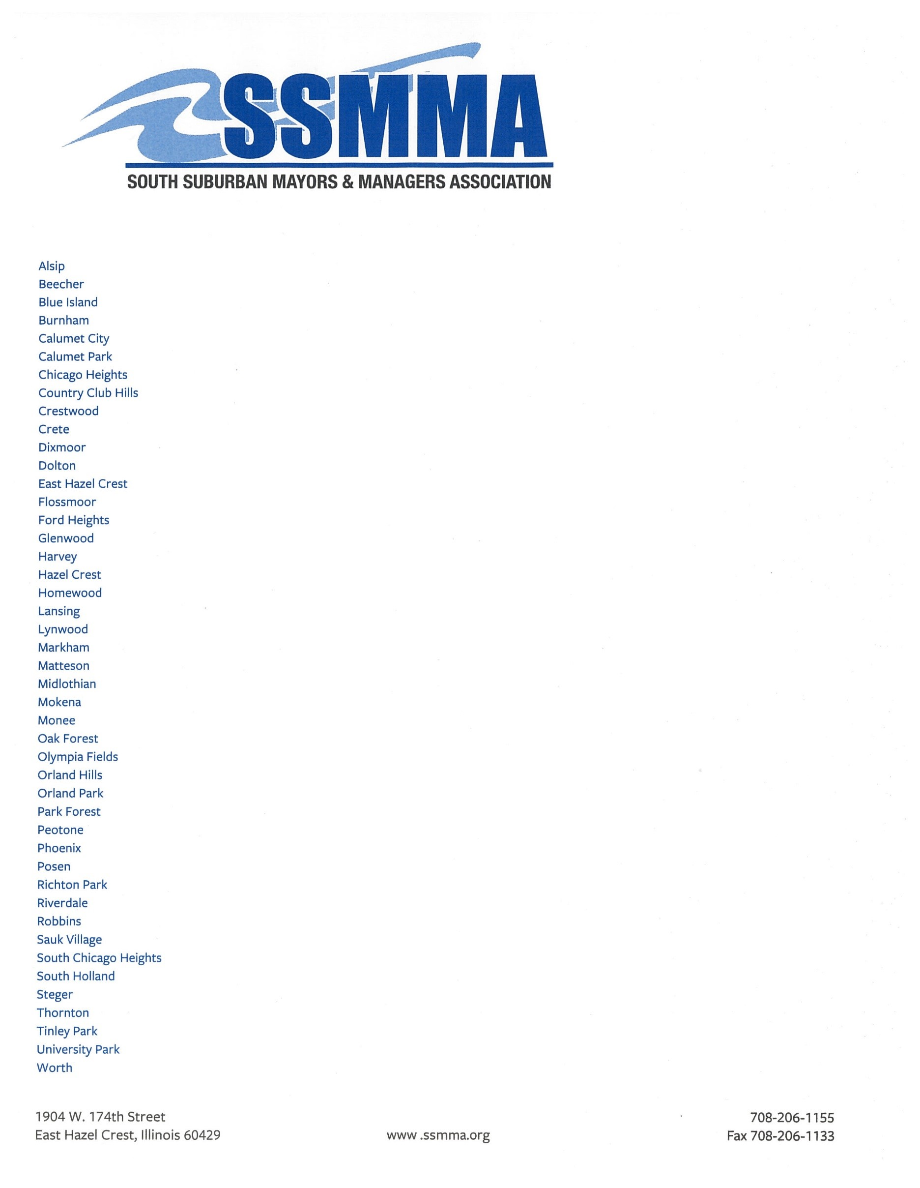
ry

Transportation Committee Meeting
March 7, 2023
2:00 p.m.
Zoom

- Call to Order

- Approval of Minutes
- February 7, 2023

- Agency Reports
- IDOT Planning and Programming – Earl D. Dunn
- IDOT Local Roads – Kevin Stallworth
- Cook County Department of Transportation and Highways –
Benet Haller
- Will County Division of Transportation- Christina Kupkowski
- Illinois Tollway- Kelsey Passi
- CMAP- CMAP staff
- RTA – Anthony Cefali
- Pace – Jessica Rybarczyk
- Metra – Noe Gallardo

- STP: Leslie Rauer

      - STP
        - March Status Updates
        - Call for Projects 2024

- Grants
      - STP- Shared Fund –March 10, 2023
      - CMAQ/TAP – March 10, 2023
      - Invest in Cook – March 17, 2023

- Next Meeting
      - TAG: March 21, 2023 at 1pm
      - Transportation Committee : April 11, 2023 at 2pm- Zoom
      - Shared Fund Priority Points : March 28, 2023 at 1pm - Zoom

- Adjournment

